Intelligent Networking, AI and ML White Paper Outline
Revision History and control
Rev | Date | Author | Description | Reviewed
V03 | 05 July 2021 | Massimo Banzi (TI)  Beth Cohen (Verizon)  Steve Casey (Verizon) | Definition sections, survey analysis | EUAG Team
V01 | 15Apr2021 | Beth Cohen (Verizon) | Creation of original document and outline of paper. | EUAG Team
V02 | 13May2021 | Beth Cohen (Verizon) | Outline with some text. Asking for input from the EUAG Team | EUAG Team

White Paper Assumptions and Overall Objectives:
- Audience: Technical and strategic leaders in the Telecom Industry interested in understanding the role of intelligent tools, AI and machine learning can have in support of their network infrastructure, customer .
- 7-10 Pages in length total – possibly will be some separate related papers on specific use cases and other information that does not fit into this one
- Do not declare or propose a definite solution just share EUAG Operator community point of view
- Purpose of White Paper is to share information about EUAG member companies’ approaches to network intelligence
https://wiki.lfnetworking.org/display/LN/Intelligent+Networking%2C+AI+and+Machine+Learning+White+Paper

- Paper Overview: Based on the findings of a LFN sponsored survey of over 60 operators and vendors in the telecom segment, demonstrate the current state of adoption of the AI/ML technology for operators.
- Make recommendations for where Open Source communities should be focusing their resources to further the intelligent networking efforts.
- Call to action. Market and executive orientation. Purpose is to get people excited about Intelligent Networking as emerging technology and its importance, yet have an understanding of where the gaps are in both the technology and its adoption.. Bullet list of gaps. 2-3 bullet items. Identify missing Open-Source tools and potential projects.

Intelligent Networking, AI and Machine Learning
White Paper
A Telecommunications Operator’s Perspective

Authored by the Members of the Linux Foundation End User Advisory Group
Lei Huang (CMCC)
Yuhan Zhang (CMCC)
Massimo Banzi (Telecom Italia)
Beth Cohen (Verizon)
Steve Casey (Verizon)

Version 3 Draft
Date: 5 July 2021

Table of Contents
1 Intelligent Networking, AI and ML White Paper Outline 1
2 Key Takeaways 1
3 Overview 1
3.1 LFN EUAG: Role and Mission 2
4 Problem Statement 2
4.1 Definitions – What is Intelligent Networking, AI/ML and AI Ops? 4
4.2 Assumptions 5
5 Survey Says…Current State of the Industry 6
5.1.1 Evaluation Model 6
5.1.2 Survey Results 7
5.1.3 Conclusions 10
6 Intelligent Networking Challenges 10
7 Feasibility 11
8 Next Steps and Recommended Actions 12
8.1 Intelligent Networking Recommendations 12
8.2 Promoting Open Source Projects 12
9 Conclusion and Call to Action 13
10 Glossary 13
11 Extra Text 14

Key Takeaways
- The industry needs to deliver new services quickly and efficiently.
- A shared understanding of intelligent networking needed to optimize interoperability.
- Some AI/ML is in place, but more research and development needed to establish best practices.
- The Open Source community can play a key role in furthering the development of frameworks and best practices.
- Start simple – Learn to trust your data and results
- Address the low hanging fruit first -- Anomalies, Forecasts, Statistical Models
  - Creating the data lakes is difficult
  - Within a company across business units
- Security and privacy concerns hamper data gathering efforts
- Need to create cross industry anonymized data. Creating a shared data model to test the algorithms
- Be prepared for bias and unintended or unexpected results if the AI/ML system is too much of a black box.
- What we need is a common framework to work with, to understand what data we need and how it can be applied to address the problems.

Overview
For telecoms to offer next-gen connectivity such as 5G, to customers and end users, they need to first optimize their networks – and AI, machine learning and AIOps offers a smarter and quicker way to achieve these objectives. This document will explore what intelligent networking means to telecoms, vendors and customers, and how AI and ML technologies and tools can be used. The cultural shifts the industry needs to make it a success, and what to bear in mind when deploying machine learning across a telco network.

As Software Defined Networking becomes more robust, operators have found that it isn’t enough to just convert everything to software and step back and expect it to all work. This is where injecting a bit of intelligence into a network can make the difference.

The LFN (Linux Foundation Networking) End User Advisor Group (EUAG) is publishing this document to identify and highlight the latest thinking and recommendations for building and supporting intelligent networking and the tools needed to achieve it. We will touch on the state of automation and adoption of intelligent networking tools by the Telecom operators. This is a new area for many in the Telecom industry, so we will focus on the requirements and some tools and approaches that have been deployed, plus explore some potential futures for intelligent networks and AI/ML tools.
We are just starting on this journey to incorporate AI/ML tools into our networks to create truly intelligent networks, so let us explore what is real today and what is still to be discovered.
- First, I will look at the fundamental issues and challenges that we looking to solve with Intelligent Networking
- I will then talk about the components and data that is needed
- Next I will share some results from a February 2021 survey of telecom operators and vendors in the industry ecosystem about the current state of adoption.
- Next, how intelligent networking can be incorporated into networks to improve operations and ensure that the solutions work as expected in production networks environments.
- Finally, I will talk about the direction the industry is going in, some key takeaways and how you can contribute to the next generation of intelligent networking tools.

LFN EUAG: Role and Mission
The LFN (Linux Foundation Networking) End User Advisor Group (EUAG)’s mission is to share views, challenges, and best practices among organizations in the telecommunications industry; particularly highlighting areas of opportunity for Open Source developer communities. The membership is individuals from various organizations from the industry including telecommunications carriers, cable operators, network providers, and compute or storage service providers.

As the voice of the operator end user community, it represents the operators’ perspective for various telecommunications related Open Source projects, and their adoption in the industry. Recent projects that the EUAG have been active with include ONAP (BSS/OSS orchestration tooling) and to lesser extent, the Anuket Project’s VNF infrastructure reference models, and testing functions stemming from the CVP (Compliance and Verification program for the NFV/SDN/VNF Ecosystem) and former OPNFV work.

Problem Statement
Most of us are technologists, but the reality is that there is constant pressure to increase the efficiency and capacity of the telecom operators’ infrastructures to delivery more services to customers for lower operational costs – to make the business work more efficiently. The software industry, leveraging virtualization, cloud native approaches, agile methodologies, and test-driven development has long been able to build applications and infrastructure flexible enough to be seamlessly modified multiple times a day.

Can and should the Telecommunications Industry, with its stringent requirements for high availability, and its distributed service delivery models, adopt these methodologies for its own infrastructure and systems? With the increased adoption of all the new SDN technologies – SD WAN, SASE, cloud networking, and more pressure to support Cloud, 5G, MEC and Edge computing the answer is that it is time for the Telecom Industry to apply intelligence to improve the performance of its own infrastructure and provide smarter tools for its customers.

Based on the information shared by participating operator and vendor organizations, the level of sophistication about intelligent networks is still relatively low, with little cross-departmental and cross community sharing or tools. With the tools and technology still in its infancy, that leads to further silos, fragmentation of development and research activities and less efficiency across the industry.
One of the most pressing problems is the lack of an understanding of the data that is needed to successfully apply machine learning to improving network efficiencies.
Why we need to work together to define the data lakes – validation of the data across the industry.
There is a need for AI tools both in support of internal processes as well as customer facing tools. Need to talk about how they diverge.
Where does the data come from?
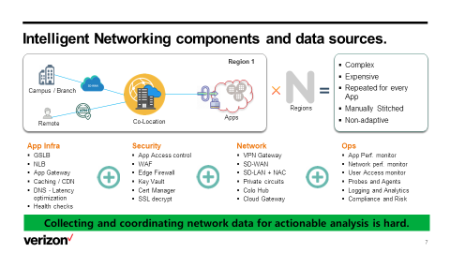

It has been said that data is king and that is certainly true for any kind of AI tools. Not only is there a very long list of components that need to be part of the Intelligent network, but capturing the data – the right data and at the level of granularity that is needed to produce results is still very much more an art than a science.
Machine learning needs lots of data, the more data it has to analyze, the more effective the results will be. As an example of this phenomenon, the problem of how to translate texts effectively and efficiently was long thought to be unsolvable. Then Google threw 30 million pages of texts at the problem – call it the brute force method, but it worked. Will it is far from perfect, certainly not at the level of Star Trek’s Universal Translator, Google Translate is a reasonably workable method of text language translation.
The amount of data needed to track network workflows to effectively create AI tools that will be able to do real-time predictive modeling. The industry is in need of better data lakes and models.

Definitions – What is Intelligent Networking, AI/ML and AI Ops?
A place to start is to have a common definition of what intelligent networking is.
We report for the purpose of this paper, the definition given by the High-Level Expert Group on AI of the European Commission resulting at the end of a study to find the best definition of AI [i]

Artificial intelligence (AI) systems are software (and possibly also hardware) systems designed by humans that, given a complex goal, act in the physical or digital dimension by
- perceiving their environment through data acquisition,
- interpreting the collected structured or unstructured data,
- reasoning on the knowledge, or processing the information, derived from this data and
- deciding the best action(s) to take to achieve the given goal.
AI systems can either use symbolic rules or learn a numeric model, and they can also adapt their behavior by analyzing how the environment is affected by their previous actions.

Similarly ISO/IEC 2382-28 [v] defines AI as "an interdisciplinary field, usually regarded as a branch of computer science, dealing with models and systems for the performance of functions generally associated with human intelligence, such as reasoning and learning".

So, as a scientific discipline, AI includes several approaches and techniques, such as
- machine learning (of which deep learning and reinforcement learning are specific examples),
- machine reasoning (which includes planning, scheduling, knowledge representation and reasoning, search, and optimization), and
- robotics (which includes control, perception, sensors and actuators, as well as the integration of all other techniques into cyber -physical systems).”
- In computer science AI research is defined as the study of "intelligent agents": any device that perceives its environment and takes actions to achieve its goals.

Even AIOps (Artificial Intelligence for IT Operations) have different but similar definitions
According to Gartner [ii], AIOps combines big data and machine learning to automate IT operations processes, including event correlation, anomaly detection and causality determination.
At TechTarget [iii] AIOps is an umbrella term for the use of big data analytics, machine learning (ML) and other artificial intelligence (AI) technologies to automate the identification and resolution of common information technology (IT) issues. The systems, services and applications in a large enterprise produce immense volumes of log and performance data. AIOps uses this data to monitor assets and gain visibility into dependencies without and outside of IT systems.

TMForum has a specific Work Group where the impact of the introduction of Artificial Inteliigence on IT Operations is studied in detail [vi]

Within the networking and telecommunications industry, AI and machine learning is focused on how we can automate the optimisation of the network.
A specific group in ETSI named Experiential Network Intelligence (ENI) is working on that and delivered a glossary defining all related Tems [iv]
But ETSI-ENI it also investigates how AI can be applied to the network working on “Autonomous Networks” i.e. set of self-governing programmable and explainable systems that seamlessly deliver secure, context-aware, business-driven services that are created and maintained using model-driven engineering and administered by using policies [vii]
The topic is so importante that also within TMForum there is a project focused on the definition of fully automated zero wait, zero touch, zero trouble innovative network/ICT services for vertical industries’ users and consumers, supporting self-configuration, self-healing, self-optimizing and self-evolving telecom network infrastructures for telecom internal users, delivering Business [viii], and Technical Architecture for this [ix].

[i] https://ec.europa.eu/digital-single-market/en/news/definition-artificial-intelligence-main-capabilities-and-scientific-disciplines
[ii] Source gartner - https://www.gartner.com/en/information-technology/glossary/aiops-artificial-intelligence-operations
[iii] Source TechTarget - https://searchitoperations.techtarget.com/definition/AIOps
[iv] ETSI GR ENI 004 V2.1.1 (2019-10) - https://www.etsi.org/deliver/etsi_gr/ENI/001_099/004/01.01.01_60/gr_ENI004v010101p.pdf
[v] ISO/IEC 2382-28
[vi] TMForum Industry Guideline - IG1190 AIOps Service Management Suite v20.5
[vii] ETSI GR ENI 010 V1.1.1 (2021-03) Evaluation of categories for AI application to Networks - https://www.etsi.org/deliver/etsi_gr/ENI/001_099/010/01.01.01_60/gr_ENI010v010101p.pdf
[viii] TMForum Industry Guideline - IG1218 Autonomous Networks Business Requirements and Architecture v1.1.0
[ix] TMForum Industry Guideline - IG1230 Autonomous Networks Technical Architecture v1.0.0

Assumptions
- The Open Source communities and standards bodies are in the best position within the industry to develop some of the tools
- Intelligent Networking is something that is of common interest across the industry
- Creating a shared understanding is beneficial to the entire industry – it is not a competitive advantage to have access to better AI tools.
- Need to be careful about how to share data and results across competing companies.

Survey Says…Current State of the Industry
Purpose: Investigate current needs and status of network automation and intelligence in the telecom industry
study development trends, refine common needs, and discuss in depth how to use open industrial cooperation models to consolidate industry consensus, unify technical routes, research and development reference realization, formulate industry standards, promote the network from automation to intelligence.
Speaking generally about the industry, I am involved in the end user group (EUAG) of the Linux foundation networking project, which is creating a white paper on what’s happening in AI and machine learning space within telecom– based on the survey that I will be sharing some tidbits from. The responses as we will shortly see, made it clear that it is still very early in the adoption cycle.

Evaluation Model
The first step in any research project is to identify the criteria for evaluating the findings and establish the assumptions that are part of that evaluation. The following are the criteria that were used to evaluate the data.
- Overall industry type and size of respondents: Respondent profiles
- Resource capacity: Level of interest in developing intelligent networking tools.

Purpose：Investigate current needs and status of network automation and intelligence in the telecom industry
study development trends, refine common needs, and discuss in depth how to use open industrial cooperation models to consolidate industry consensus, unify technical routes, research and development reference realization, formulate industry standards, promote the network from automation to intelligence.

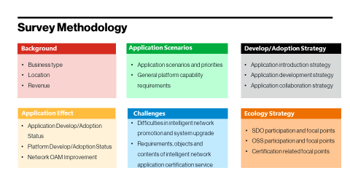

Survey Results
- Current overall progress
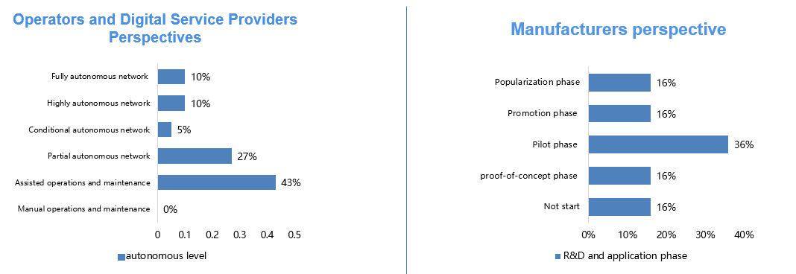
Figure1  Current overall progress
AS shown in Figure 1, viewed at the Operators and Digital Service Providers Perspectives, in six levels, from manual operation to fully autonomous, most operators are at the Assisted Operation & Maintenance level of autonomous network, in this autonomous level the system executes a specific, repetitive subtask based on pre-configuration in order to increase execution efficiency. Only about a quarter of operators and digital service providers are at conditional autonomous level or above.
And viewed at Manufacturers perspective, most manufacturers have adopted some AI technology in their network. At pilot R&D and application phase. Only 15% of the manufacturers Have a long-term plan for scale adoption into their infrastructure or product.
- Strategy for improving network intelligence
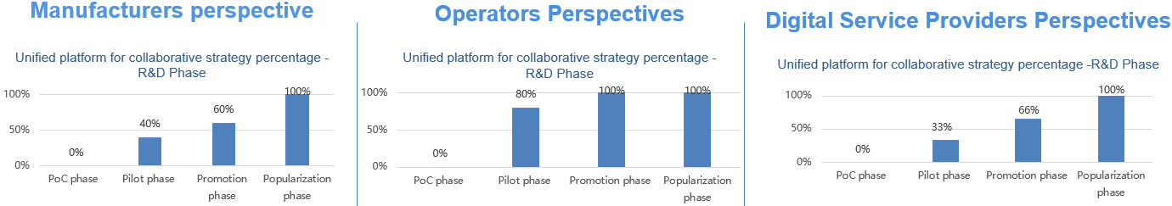
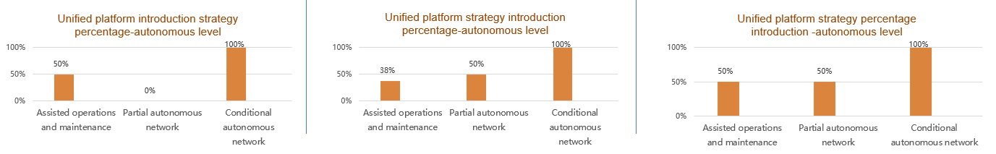
Figure 2 Strategy for improving network intelligence
Respectively to extract the Manufacturers, operators and digital service provider sample, observed the evolution trend for different R&D phase of network intelligent collaborative strategy adopted by the company, we can find that the higher research and development phase, The higher the percentage of adopting the strategy that Build an AI platform suitable for all intelligent network application scenarios. rather than coordinate different vendor solutions at the network element level, or implement an end-to-end process using AI tools.
Respectively to extract the Manufacturers, operators and digital service provider sample, observed for the autonomous level achieved by companies with different introduction strategies, we can find that the company which Build a unified AI platform suitable for all intelligent network application scenarios have a relatively higher level of network autonomous. and company that achieve conditional autonomous level all choose the adopt a unified platform strategy for improving network intelligence.
Investigating the functions that need to be provided by the intelligent general platform of the network, we get the results as follows, most of the respondents responded they will through a unified intelligent platform to Provide basic AI algorithms, algorithm frameworks, training capabilities, etc., About 60%. More than half of the respondents responded they more focus on the Define data access capabilities and provide raw data, training data and subject data to other functions or capabilities through access and processing of external data sources. Less than half of the feedback network intelligent general platform needs to provide functions including - Based on intelligent network capabilities, provide common business capabilities and applications, and Unified R&D and deployment of general intelligent network capabilities for various intelligent network applications, and provision of trusted AI capabilities.
- Requirements of application scenarios
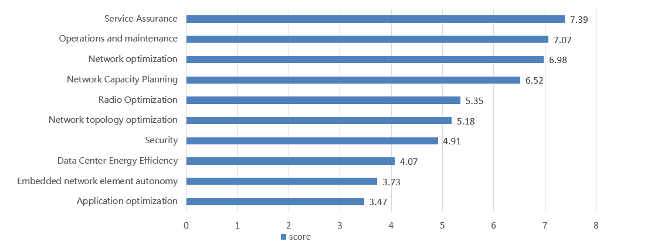
Figure 3 Requirements of application scenarios
We also surveyed the AI application scenarios that respondents were most concerned about, the result is that the top three AI application scenarios are Operations and maintenance, Service Assurance, and Network optimization, due to these scenarios are serving customers and front-line operations. which is the industry being most interested in.
Autonomous network elements, energy efficiency, and application optimization are generally low in the rankings due to their own difficulty and they are not under operators’ own control. it's not the focus of the industry right now.
- Ecology strategy
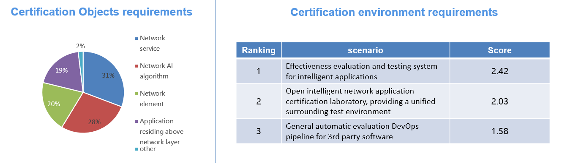
● Figure 4 Ecology strategy
As for the Ecology strategy, The primary objects of intelligent network application certification are network service and AI algorithm, they are 31% and 28% respectively. Secondary certification objects are intelligent network elements and applications residing above network layer. about 20% respectively.
Building a test and certification service for intelligent network solutions, the most important is to provide effectiveness evaluation and testing system for intelligent applications. Secondly, is to provide an Open intelligent network application certification laboratory, and providing a unified surrounding test environment and General automatic evaluation DevOps pipeline for 3rd party software.
As a result, we need aimed for intelligent network service and network AI algorithm to provide effect certification specification, and also need to provide open network intelligent certification service
In terms of survey feedback groups, O-RAN, 3GPP and ITU-T participated the most in standard organizations. 24%, 13%, and 13% of respondents participated, respectively. The open-source communities ONAP, O-RAN accounted for close to half of the participants.,25% and 21% of respondents participated, respectively.

Conclusions
- On the whole, the industry intelligence networking transformation is in the initial phase, the level of maturity about intelligent networks is still relatively low.
- The key finding of the strategy of improving intelligent networking is that Leading operators and manufacturers generally adopt a unified AI platform to introduce and coordinate intelligent network applications. The unified platform is conducive to improving the level of autonomous network.
- We should pay more attention to the operations and maintenance, Service Assurance, and Network optimization AI application scenario, which are the industry most interested in.
- For ecology system, the key finding is that industry network intelligence transformation company focuses on participating in the O-RAN, 3GPP SA5 and ITU-T standards organizations, as well as the ONAP, O-RAN and TIP open-source communities. And we need aimed for intelligent network service and network AI algorithm to provide effect certification specification.

Intelligent Networking Challenges
There are many challenges in improving network intelligence. From the results of the survey, Operators as the consumers of network intelligent technology, lack of a controllable network experiment environment, shared and open network data sets, AI talent and technical reserves are the long-term common challenges faced by both initial autonomy and higher level. Leading operators generally face the challenge of network element standardization and data normalization.
From the manufacturer’s perspective, Network element standardization and R&D environment are the common challenges faced by manufacturers at present, do not trust intelligent network control is the main challenge for manufacturers to continue the long-term planning of network intelligent products.
Operators need normalized data, with the development of intelligent network, there is a benefit to share data between operators and vendors, how to have a shared data model across the industry is also a big challenge in the intelligent network.
With the introduction of NFV architectures, the resource pool and network element tests need to be conducted separately. Because pairing tests are needed between resource pools and network elements that by necessity increases both the test types and the frequency of the testing.
AI and machine learning is pretty new. Many telcos have done optimisation by hand over the years – looking at historic data and tweaking networks – but what has changed recently is the ability to do it more in real time. The tech is still evolving and the adoption is still evolving.
Network management needs to be turned on its head. There are opportunities to inject intelligence at all these different points, from the customer experience, automatic portals that anticipate customers’ needs and interests at the front end.
From the operator’s perspective, the more fruitful targets for automation and AI are on the infrastructure end, the operations and network management. AI and machine learning is pretty new.

Feasibility
Using the results from the survey s to automate the following elements to be successful: test environment What would you say is the most important principle of rolling out AI and machine learning within a telco?
Test! Don’t be afraid to go out there and do it. Performance testing is very important – this is not something the vendors particularly like, but at Verizon we find we need to do deep testing before we can roll anything out to our customers. We do extensive integration testing, putting the components into a lab and beating the hell out of them to see when failover occurs, which means that we can be comfortable supporting our customer SLAs.
Many vendors cannot do this kind of deep testing, as we are testing on real, production networks. This is different from pumping data through in a lab. We have found that vendors converting from physical to virtual hardware often do not understand what needs to go into that virtualisation – you can’t snap your fingers and put an ISO on there, you really have to tune it. You have to add DPDK, SR-IOV capability, and other types of tuning to make sure it works with the virtualised infrastructure.

Yes, we have come a long way in building the intelligent network, but don’t be fooled, the Real-Time enterprise requires lots of integration work to pull together all the components that are needed to support it. It is not just a matter of dropping in some new equipment; it requires fundamental changes to the very business delivery model itself. The very nature of how we support networks has to change. And not only one component has to change, but all the piece parts need to change in a coordinated manner.
We acknowledge doing what has done already may appear to be simple. Just be sure you’ve considered everything. It’s a lot to think about – and a lot to take on.

Next Steps and Recommended Actions
Given its relative immaturity, it is recommended. What cultural shifts are required within telcos to make AI and machine learning a success?
20 years ago, many companies had friction between their network engineers and their telecoms engineers - then someone got the brilliant idea of ‘They’re both doing the same thing, so why not put them in the same organisation?’ I see something similar happening in AI and ML as we go down this journey. In many cases, the applications and networks need to work together, because at the end of the day companies and people are interested in how the application performs. They don’t care about the network underneath, even though we as operators do.
I always say we are creating application aware networks, even though I don’t see the app developers doing much on making network-aware applications.

Intelligent Networking Recommendations
Given its relative immaturity, it is recommended.

Promoting Open Source Projects
In conclusion, while there have been
What role is open networking playing in AI and machine learning?
Similar to what’s happening in 5G, which is emerging from Open RAN and other industry work within the open source and standards bodies, I see AI and ML coming out of open source consortia. I think this has to be the case – operators are used to working across each other, as we’ve been peering for years! Things are not quite the same on the vendor side.
One example is the use of Open Source as mechanism to manage the integration. VZ has leveraged this to its advantage to build the required infrastructure faster. However well the need for these new technologies is recognized, there are significant challenges to achieving this vision for supportable testing frameworks. NFV testing complexity hampers service agility and time to market; the two most important factors for adoption of NFV architectures. The situation is further aggravated by the different SDO (Standards Organizations) and OSC (Open Source Communities) having both overlapping and conflicting objectives of the few standards that do exist, with no shared definition of how to support Day 2 operations infrastructure changes. This has resulted in unnecessary barriers for vendors, promoted technology silos and increased complexity across the industry in general.
As NFV applications and workloads mature, hardware and software disaggregation will increase with more multi-vendor solutions, requiring a more detailed understanding of the virtualized environments and more integration testing.
The complexity of interoperability testing is increasing with the introduction of multi-vendor solutions replacing monolithic legacy systems.
The community is interested in reducing the risks associated with implementing NFV systems brought to market before standards are available.
Operators and vendors increasingly see the value of using reference models, architectures, and standardized testing to assure that vendor NFV software is compatible with infrastructure designed to support telecom NFV workloads (NVFI).
Commodity hardware with built-in hardware acceleration (Smart NIC, FPGA, GPU) will be standard infrastructure components.
Virtualized components need to support multiple NFVIs and shared physical resources.

Conclusion and Call to Action
In conclusion, while there have been some efforts to create standard testing frameworks to support the new NFV architectures needed for the telecom industry, there is still a long way to go towards having a common platform and understanding ly.

Glossary
OSC | Open Source communities
SDO | Standards Organizations
CSP | Communications Service Providers
LFN | Linux Foundation Networking
EUAG | End User Advisory Group, a working group within the LFN

Extra Text
AI, machine learning and AIOps: the next frontier of networking
For telcos to offer next-gen connectivity to customers and end users, they need to get their own houses in order first by optimising their networks – and AI, machine learning and AIOps offers a smarter and quicker way to do it. We spoke to Beth Cohen, SDN Technology Strategist at Verizon, to discover what AI and ML means to Verizon and other telecos, the cultural shifts the industry needs to make it a success, and what to bear in mind when rolling out machine learning across a telco network.

AI, ML and AIOps mean different things to different organisations. How should we understand them in the telco context?
Within the networking and telecommunications industry, AI and machine learning is focused on how we can automate the optimisation of the network. There are two aspects to this – telcos doing it for their own infrastructure, to make sure networks, connections and so on are working optimally as traffic shifts; then providing similar tools to customers to optimise their own networks.
Do these two aspects run side by side?
In Verizon, one led to the other. We started implementing AI and machine learning internally on our own infrastructure, and we have since started to extend these capabilities to our customers. Since SD-WAN networks have some optimisation built in as an integral part of their functionality, this had led to us going down that path with our customers too.
How is machine learning helping Verizon automate?
AI and machine learning is pretty new. At Verizon we have done a lot of optimisation by hand over the years – looking at historic data and tweaking networks – but what has changed recently is the ability to do it more in real time. Speaking generally about the industry, I am involved in the end user group (EUAG) of the Linux foundation networking project, which is creating a white paper on what’s happening in AI and machine learning space within telco. We carried out a survey with both operators and vendors. The responses made it clear that it is still very early in the adoption cycle. The tech is still evolving and the adoption is still evolving. We at Verizon started our journey a few years ago – but it’s still early days in the technology adoption cycle.
What cultural shifts are required within telcos to make AI and machine learning a success?
20 years ago, many companies had friction between their network engineers and their telecoms engineers - then someone got the brilliant idea of ‘They’re both doing the same thing, so why not put them in the same organisation?’ I see something similar happening in AI and ML as we go down this journey. In many cases, the applications and networks need to work together, because at the end of the day companies and people are interested in how the application performs. They don’t care about the network underneath, even though we as operators do.
I always say we are creating application aware networks, even though I don’t see the app developers doing much on making network-aware applications. At Verizon we are creating more tools to allow developers to take advantage of the network, particularly driven by 5G initiatives. We are building a fantastic 5G network and the applications need the tools to take advantage of it.
What role is open networking playing in AI and machine learning?
Similar to what’s happening in 5G, which is emerging from Open RAN and other industry work within the open source and standards bodies, I see AI and ML coming out of open source consortia. I think this has to be the case – operators are used to working across each other, as we’ve been peering for years! Things are not quite the same on the vendor side.
What would you say is the most important principle of rolling out AI and machine learning within a telco?
Test! Don’t be afraid to go out there and do it. Performance testing is very important – this is not something the vendors particularly like, but at Verizon we find we need to do deep testing before we can roll anything out to our customers. We do extensive integration testing, putting the components into a lab and beating the hell out of them to see when failover occurs, which means that we can be comfortable supporting our customer SLAs.
Many vendors cannot do this kind of deep testing, as we are testing on real, production networks. This is different from pumping data through in a lab. We have found that vendors converting from physical to virtual hardware often do not understand what needs to go into that virtualisation – you can’t snap your fingers and put an ISO on there, you really have to tune it. You have to add DPDK, SR-IOV capability, and other types of tuning to make sure it works with the virtualised infrastructure.
Is there a culture of testing in our industry?
Telcos have been testing forever. We are doing more integration testing than we ever did before. Previously we relied on vendors testing the boxes they supplied, but when we receive a virtual machine application that acts as a router, we no longer trust that the vendor is able to do the full degree of testing that they were doing before, because they no longer have control over the infrastructure.
How can telcos balance speed and availability in their rollouts?
High availability can mean different things. It previously typically meant two boxes with failover. Now things are a lot more complex – some components are in the cloud, some are at the edge, and so on. This falls on us as operators to do the integration, do the testing, and make sure it works.
You will discuss AI, ML and AIOps at the Layer123 360 Network Automation Congress on 14 April. What can we expect from your talk?
I will talk about AI and ML as the next frontier of networking. We’re just starting on that journey at Verizon and we expect great things – but as with all tech, it ends up taking twists and turns and doing something totally different than we first thought!

- Enterprises are looking for ways to innovate on a number of fronts: deliver services and applications faster then before, deliver world class customer experiences, manage costs, future proof investments that are dynamic, can scale rapidly, and can evolve with customer and technology demands
- In order to do this, enterprises must:
  - Rethink network connectivity. Applications require different types of connectivity to ensure quality delivery and flawless customer experience
  - Enterprises should think in terms of an integrated hybrid connectivity platform that can be comprised of a mixture of MPLS, Public Internet, Broadband, and Ethernet services
    - Attributes of the hybrid connectivity platform are; Programmable, agile, on-demand, and automated
    - This hybrid connectivity platform is also orchestrated with the SDN and Virtual Services layer. This is want enables enterprise customers the ability to
      - Deliver network and security services on a micro – services basis. Customers can reduce costs by reducing their hardware footprint and virtualizing their application environment
      - Security services, WAN optimization services, SDN services, routing services can now be delivered in a commercial model whereby customers only pay for the services they need. For example, an enterprise may need only a ‘base’ set of security services for 9 months out of the year and premium security services for the other 3 months. Verizon can enable this flexibility and the customer ONLY pays for the level of service delivered when the customer needs them. And the delivery mechanism is software enabled so the capabilities are implemented by pushing the software features to all locations that need them, i.e. just like cloud native services.
  - Roadmap: the integration of the hybrid network platform with the SDN/VNS stack will enable a highly intelligent and automated network as a service platform which will be able to identify user or network behaviors and then automate decisions that can action against those behaviors in near real time. For instance, DDoS attacks can be instantly identified, the existing virtual security port can be disabled and a new virtual security instance spun up in seconds. This keeps an enterprise’ operations up while enabling the security team to forensically address the DDoS attack.
  - Customer Benefits of moving to an SDN enabled Hybrid Connectivity Platform
    - Reduce costs by decreasing hardware footprint and moving application services to a microservices commercial model (pay for application service level you need, when you need it)
    - Become highly agile by virtualizing the application environment. Customer site types can be predefined. Any new site deployment can be deployed base on the predefined templates and the application services can be pushed out to the site.
    - Contract, procurement, and engineering cycles are decreased – work with a single partner who can contract services centrally
    - Operational and management of hybrid connectivity remains with a single partner who can manage the hybrid connectivity platform in addition to the SDN/Virtual Services stack versus having to deal with 4+ connectivity providers
    - Deploy Cloud First strategy in a cost effective manner. Fully integrate key CSPs into network environment. DevOps to production is instantaneous, Cloud environment and applications can scale on-demand

